**Design:**

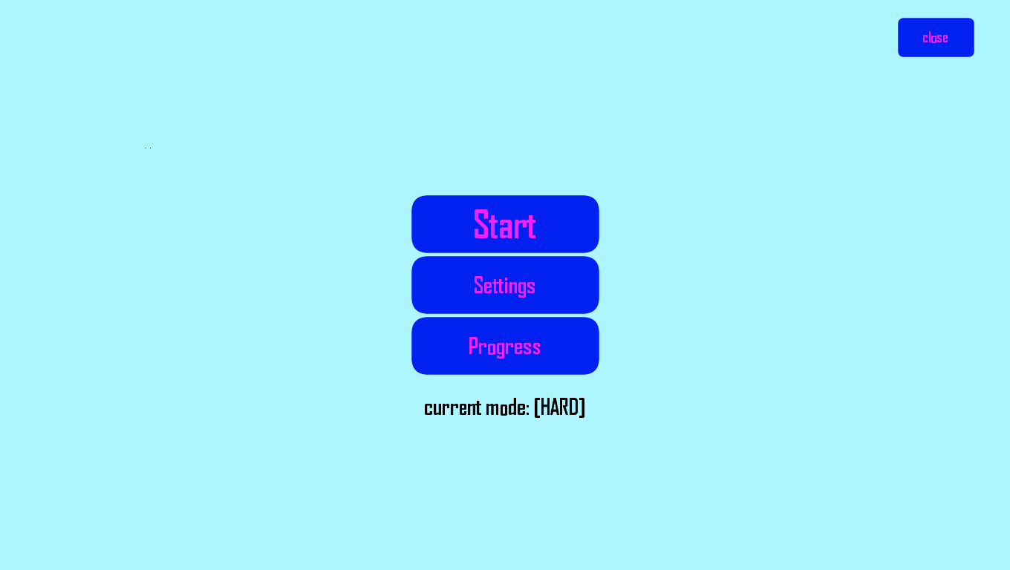

**Behavior:**

When “Start” is clicked it starts the exercise, based on the “current mode”. If “Settings” is clicked, it opens the settings menu. When “Progress” is clicked it opens the menu with the users.